Chapter No :1

Introduction

This proposal “Emergency System of MIC “is projects which will be developed to use partially fulfill the needs of Multan Institute of Cardiology.

* + 1. **Main Theme**

Emergency system of MIC is manually maintained, which has lot of drawbacks for both the patients as well as the department point of view. So the purpose to develop this website is to have the patients the hands off information about their prescription and information about MIC. Also this system is developed to have information in a speedy way without any confusion.

* + 1. **Scope of the Project**

The department should properly maintain the records of each Emergency patient and gives patients easy access to their profile in future and help to gain good and relevant knowledge. Patients will be able to find event reports just by viewing site. This portal should also provide a meeting point for patients, and staff of the department to share their information. Patients can be easily updated by the recent events, prescriptions and tests just by viewing the site. MIC can offer workshop to the patients and doctors in the field of cardiology. Patients can even print their prescriptions and tests and can view Doctor’s schedule.

* + 1. **Objectives of the Project**

The objectives are to:

1. Easily maintain the records of patients.
2. Patients can be benefited by viewing information online.
3. Doctors can check the patient history easily.
4. To give Emergency staff easy access to patients files.
5. Provide platform for sharing ideas and experiences.
6. Online pole to cast MIC information.
   1. **Organization**

The organization which is studied for final project is Multan Institute of Cardiology that is located at Abdali Road, Multan near Ramada Hotel. Health Department is one of the largest Departments of the District serving its population right at their door steps through an elaborate system of field workers, primary, secondary & tertiary level care facilities. The Health Department at district level is performing primary & secondary level care facilities. The tertiary level care, undergraduate & post graduate medical education is being provided by Nishtar Medical College & Hospital, which is an autonomous medical institution. The Multan Institute of Cardiology and Children Hospital Complex are specialized autonomous Hospitals. The Health Department at District levels headed by Executive District Officer Health. Development of modern center for treatment of heart diseases and large vessels has been dream of specialists in this area. This dream has been realized due to sympathetic and humanitarian approach of Ch. Perez Elahi Chief Minister Punjab. 1.2.1 **Hierarchy of hospital management system**  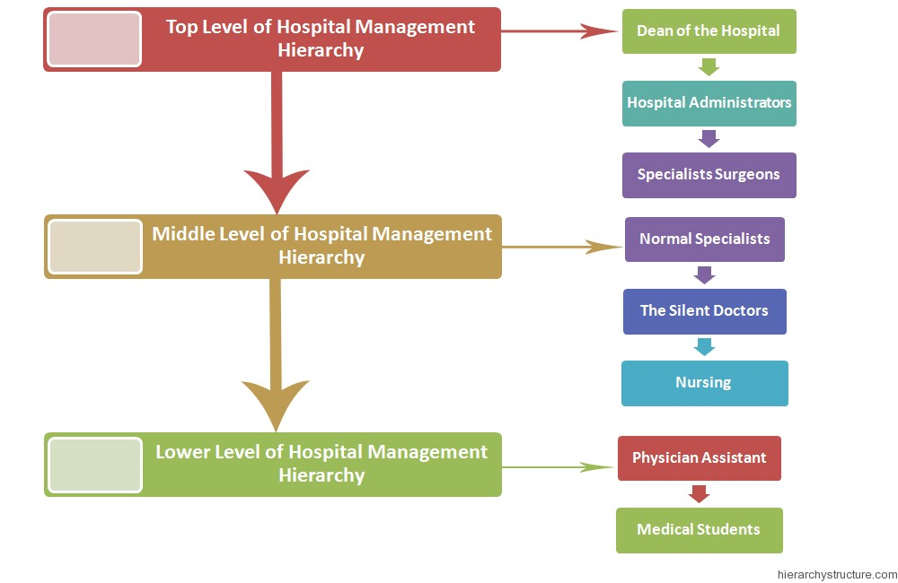

**1.2.2 Main Aim and Work Environment**

1. Consultation by Doctors on Diseases.
2. Diagnosis for diseases.
3. Providing treatment facility.
4. Facility for admitting Patients (providing beds, nursing, medicines etc.)
5. Immunization for Patients/Children.
6. Recording information about the Patients that come.
7. Recording information related to diagnosis given to Patients.
8. Keeping record of the Immunization provided to children/patients.
9. Keeping information about various diseases and medicines available to cure them.

10. Maintaining records of indoor/outdoor patients.

11. Maintaining patients diagnosis details, advised tests to be done.

12. Maintaining patient’s injection entry records.

13. Maintaining patient’s prescription, medicine and diet advice details.

14. Maintaining backup of data as per user requirements (between mentioned dates).

* 1. **Conclusion and Future Prospectus:**

1. Planned approach towards working
2. Efficiency
3. Data Security
4. Accuracy
5. Flexibility
6. User friendly
7. Reliability
8. Performance
9. Comprehensive database
10. Minimize the redundancy
11. Detailed Information about Patient, Doctors and Employee.